Energy-Efficient Routing Schemes for Sensor Networks
Maleq Khan, Gopal Pandurangan, and Bharat Bhargava
Department of Computer Science,
Purdue University, West Lafayette, IN 47907
{mmkhan, gopal, bb}@cs.purdue.edu

Abstract

Keywords: Sensor Networks, Routing, Data-Centric Routing, Energy-Efficient Routing, and Self-Configuration.

- Introduction
There are some similarities between wireless sensor networks and wireless ah-hoc networks. One of the similar characteristics for both of them is multi-hop communications. Some of the routing protocols proposed for wireless ah-hoc networks can be examined in the context of wireless sensor networks. Especially the power-aware routing protocols proposed in [1, 2, 3, 4] can be explored since sensor networks have stringent energy constraint. However, these protocols may not be efficient, effective or feasible, in sensor networks. The nature of applications and routing requirements for the two are significantly different in several aspects [5]. First, the typical mode of communication in a sensor network is from multiple data sources to a data recipient/sink rather than communication between any pair of nodes. Second, since the data being collected by multiple sensors is based on common phenomena, there is likely to be some redundancy in the data being communicated by the various sources in sensor networks. Third, in most envisioned scenarios the sensors are not mobile, so the nature of the dynamics in the two networks is different. Finally, the single major resource constraint in sensor networks is that of energy. The situation is much worse than in traditional wireless networks, where the communicating devices handled by human users can be replaced or recharged relatively often. The scale of sensor networks and the necessity of unattended operation for months at a time mean that energy resources have to be managed even more carefully. This, in turn, precludes really high data rate communication.

- Related Works
Data aggregation has been put forward as a particularly useful paradigm for wireless routing in sensor networks [6], [7]. The idea is to combine the data coming from different sources enroute – eliminating redundancy, minimizing the number of transmissions and thus saving energy. This paradigm shifts the focus from the traditional address-centric approaches to a more data-centric approach [5]. In [5], address-centric and data-centric protocols are defined as follows:
Address-centric Protocol (AC): Each source independently sends data along the shortest path to sink based on the route that the queries took (“end-to-end routing”).
Data-centric Protocol (DC): The sources send data to the sink, but routing nodes enroute look at the content of the data and perform some form of aggregation/consolidation function on the data originating at multiple sources.
The authors theoretically bound the number of transmissions required in DC protocol and showed that DC protocol need fewer transmission that that of AC protocol.
Heinzelman et al [9] presented a simple analysis to show when multi-hop routing is preferable over direct communication with the objective of minimizing energy for transmission.
The above two analyses provide a good theoretical basis for using data-centric multi-hop routing in wireless sensor network. However, a rigorous theoretical model is needed to estimate energy and to find sensor placement strategy to minimize energy. In the next section, we provide a model for such analysis.
sink

Custer-Based Tree Center at Nearest Source Shortest Path Tree
Figure 1. Various schemes for data aggregation and routing. The sink can be inside or outside of the sensing area.

Several schemes have been proposed for data-centric routing in sensor networks. Cluster-based [2, 7], center at nearest source [5], and shortest path tree [5] are important among them.

Cluster-Based Tree (CBT): In this scheme, the sources send data to the associated cluster head. Cluster head aggregate data and send to the sink. Multiple levels of cluster hierarchy [2] can be another option.
Center at Nearest Source (CNS): In this scheme, the source which is nearest the sink acts as the aggregation point. All other sources send their data directly to this source which then sends the aggregated information on to the sink.
Shortest Paths Tree (SPT): In this scheme, each source sends its information to the sink along the shortest path between the two. Where these paths overlap for different sources, they are combined to form the aggregation tree.
In the next section

3 Routing Schemes to Minimize Energy Consumptions
Unattended operations and limited energy of the sensor nodes demands a routing scheme, which minimizes energy consumptions for routing data from the sources to the sink. At this point, several research questions arise: to minimize energy/cost,
1) How the sensors should be placed (sensor distribution)?
2) How many sensors should be deployed (density)?
3) Which routing scheme requires minimum energy?
4) What is the expected energy required for a given routing protocol when the sensors are placed randomly?
To answer the above questions, we begin with a simple one-dimensional sensor array shown Figure 2. For the purpose of analysis, a transmission step and a transmission phase are defined as follows.
Definition 1: Transmission Step. A transmission step is the time duration in which a node begins and completes transmitting data to the next hop.
Definition 2: Transmission Phase. A transmission phase a collection of successive transmission steps that begins with the steps when the sources start sending data and ends with the step when the sink receives data from all of the sources.
Considering data-centric routing the following assumptions are made.
Assumption 1: Each node waits until it receives data from all of its descendants and upon receiving, aggregates received data (including its own) then sends to the next hop.
Assumption 2: In each transmission phase, each source sends data exactly once.
Lemma 1: If n be the number of sensors nodes, the total number of transmissions in each transmission phase is n.
Proof: Assumption 1 and 2 lead us to the conclusion that each sensor node needs to transmit exactly once in each transmission phase. That is, the number of total transmission is n.
sink
R
n nodes

Figure 2. A simple linear network - one-dimensional sensor array.

Theorem 1: Considering a simple linear network, let the sink receive data from a distance R using n hops placed in a straight line. The total transmission energy is minimal when nodes are equally spaced, i.e. when the distance between any two neighbors is 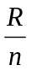, and the minimum energy consumption 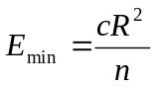, where c is the constant energy factor.
Proof: Let be the distance from node i to the next hop (Figure 2). Energy required to transmit to a distance is 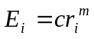, where 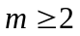 is a constant. Total energy consumption 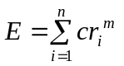. We minimize 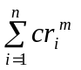with the constraint 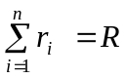. An equivalent expression to minimize is
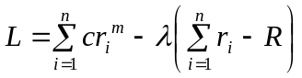, where λ is a Lagrange’s multiplier
now, 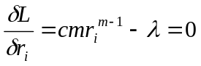, i.e. 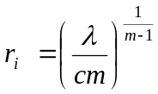.
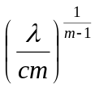 is a constant (independent of i), that is 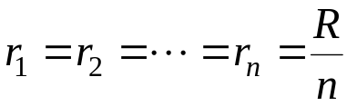. Minimum energy consumption, 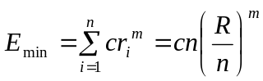. Considering m = 2, 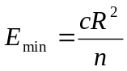.

Theorem 1 says that energy consumption is minimal when nodes are equally spaced and observe that transmission energy is a strictly monotone decreasing function of number of nodes. This observation suggests using as much sensor as possible to minimize energy consumption. However, there is a constant (independent of distance) amount of energy requirement for each transmission at the receiving end and also may be at the sending end to processing data (data aggregation and processing data packets). Furthermore, cost of sensor nodes need to be considered to find the optimal number sensor nodes. Theorem 2 gives the optimal number of sensors for a simple linear network.

Theorem 2: To minimize the total cost, the optimal number of sensors nodes in a simple linear network is 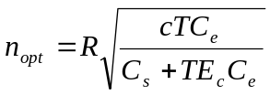, where 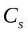and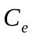are the costs per sensor and per unit energy respectively, and c, T, and 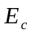 are the constant energy factor, the estimated number of transmissions phases in the lifetime of the network, and the constant amount of energy associated with per transmission.

Proof: Total variable transmission cost = 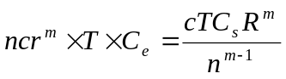, using 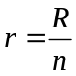.
Total fixed transmission energy (independent of transmission distance) = 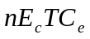.
Cost of the sensor nodes = 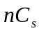.
Total cost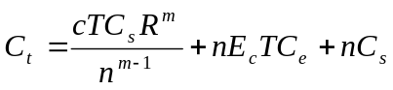.
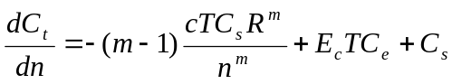, solving 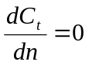, 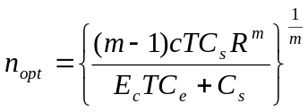
With m = 2, .

Corollary 2.1: Ignoring the cost of the sensor nodes 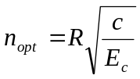.

We already have found that a transmission phase consumes minimum energy when the sensor nodes are equally spaced. However, in many applications, we may not be able to position nodes at the exact positions. Instead, we might need to through the sensors randomly in the area of interest. In such a situation, although we are not able to get the minimum energy configuration, we are interested to find the expected energy required for transmission. The following lemmas and theorems give us way to compute expected energy for random distribution of the sensor nodes. An interesting result (Theorem 3 below) to observe is that the expected energy consumption in a linear network with randomly distributed nodes is bounded by 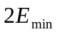, twice the energy consumption when the nodes are equally spaced.

Lemma 2: For the simple linear network model, the probability density function that a node transmit to distance r (i.e. the next hop is at distance r) is 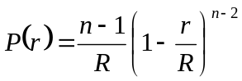.
Proof: Consider any arbitrary node N at point A shown in Figure 3. Assuming uniform distribution, the probability that a particular node is on the line segment AB of length r is 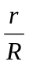.
The probability that the next hop N′ is within distance r
= the probability that at least one of the n – 1 nodes (except N) on AB
= 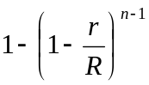
N
sink
r
N′
A
B
R

Figure 3: Randomly distributed sensor nodes

This is the cumulative distribution function. The derivative of this function is the probability density function. That is,
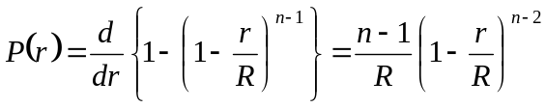
€

Note that 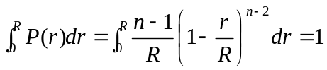 and the expected (average) distance to the next node is 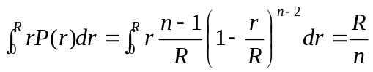, which are obvious.

Theorem 3: The expected energy consumption in one transmission phase of a simple linear network with randomly distributed n nodes is 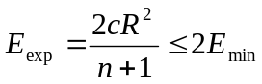.
Proof: Energy consumption for one transmission to distance r is 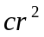. Therefore, the expected energy consumption for one transmission is
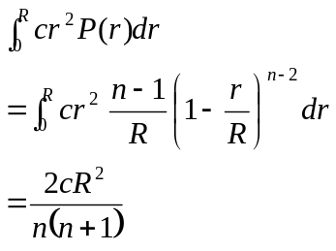, [Lemma 2]
There are n transmissions in one transmission phase [Lemma 1]. Hence, expected energy consumption in one phase is 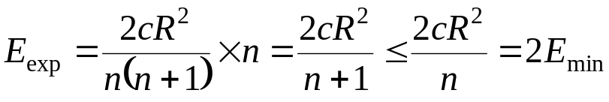 [Theorem 1].
€

4 Routing in Two Dimensional Network
In this section we examine network configuration to minimize energy consumption in routing data in a two dimensional circular area with radius R (Figure 4).
R
sink
r
sensor node

Figure 4: Sensor network in a circular area with radius R. Nodes are (uniform) randomly distributed.

Definition 3: Routing Path. A routing path is the path along which a source sends data to the sink.

Definition 4: Routing Tree. The routing paths in a network form a tree when they satisfy the conditions a) a routing path does not contain any cycle and b) if two routing paths merge at some node, they never get separated. This tree is called a routing tree.

Assumption 3: A node can be connected to (can communicate with) the other nodes, which are within a specified distance.
Definition 5: Connectivity Graph. A connectivity graph, 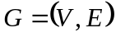, is the graph where V is the set of sensor nodes and for any two nodes u and v, weight of the edge 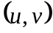, 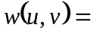the distance between u and v if u and v can communicate with each other (e.g., if they are within a specified distance), otherwise 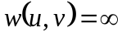.

Theorem 4: Let be the connectivity graph of the sensor nodes. A routing tree with minimum energy consumption is a minimum spanning tree on G.
Proof: Let 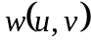 be the weight of the edge in G. Energy required for one transmission from u to v is 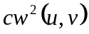. Let 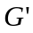 be the graph with the same vertices and edges as in G but weight for edge, 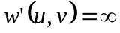 if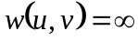, otherwise 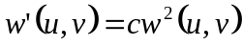, i.e., energy required for one transmission from u to v. A minimum spanning tree 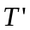 on minimizes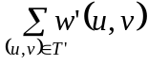, which is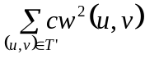, that is, minimizes energy consumption for a transmission phase.
Now we show that for all u and v, 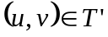 if and only if 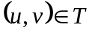, where T is the minimum spanning tree on G. Consider Kruskal’s algorithm [8] to find minimum spanning tree: the edges are sorted by non-decreasing weight, then, to form tree, edges are added one by one from the sorted list. An edge is added to the tree if u and v are not connected using the edges already added. For any two edges 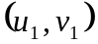 and 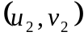, 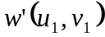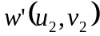 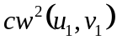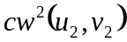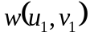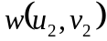, that is, the both set of weights 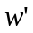and produce the same sorted order of the edges. As a result, the set of edges in is equal to the set of edges in . Since minimizes energy consumption, hence, T does so.
€

Computing a minimum spanning tree might not be feasible for the sensor nodes with low memory and computation power. A greedy approach as an approximation to minimum spanning tree is called the nearest neighbor routing. Each node gets connected and sends data to the nearest neighbor, which is not connected to this node. An algorithm to self-configure the network to form a nearest neighbor tree is given in section 4. A minimum spanning tree using Kruskal’s algorithm [8] and a nearest neighbor tree of sensor nodes are shown in Figure 5.

Minimum Spanning Tree Nearest Neighbor Tree

Figure 5: A minimum spanning tree and a nearest neighbor tree.

Lemma 3: In a two dimensional network model, the probability density function that a node transmit to distance r (i.e. the nearest neighbor is at distance r) is 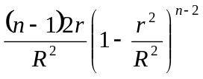.

Proof: A particular node has its nearest neighbor within distance r (Figure 4) with probability 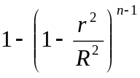. The derivative of this function, , is the probability density function.
€

Using this density function we calculate the expected energy consumption in nearest neighbor routing (Theorem 5).
Theorem 5: A lower bound on the Expected energy consumption in one transmission phase is 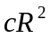, where c is the constant energy factor and R is the radius of the area covered by the sensor nodes.
Proof:
€

An interesting observation is that total expected energy consumption in a two-dimensional area does not depend on the number of sensor nodes. However, a minimum number of nodes are required to satisfy sensing coverage. Our future works include analysis of sensing coverage.

5 Self-Configuring Nearest Neighbor Tree
A nearest neighbor tree (NNT) is tree where each node is connected to the nearest among its available neighbors. We say a neighbor is available for connection if and only if a connection to that neighbor does not create a cycle. A NNT is shown in Figure 5. In section 3, we analyze the energy required for routing in such a NNT. In this section, we describe how a sensor network self-configures to form a nearest neighbor tree. Node p is a neighbor of node q if q can communicate with p, i.e. if p is within a certain distance from q. The algorithm is described below.
a. Building neighbor list: Each node broadcasts a signal with its ID and creates a list of the IDs of the nodes from which it receives signal. From the strength of the signals received, the
distances of the nodes are estimated. Based on this distance, a sorted list of the neighbors is created.
b. Getting connected: Each node maintains a descendant list to avoid cycle. Initially the list is empty. When a node, say p, gets connected to another node, say q, p sends its descendant list to q. q adds p and descendants of p into the its own list. A node selects its neighbor to get connected to, that is the nearest among the nodes that are in neighbor list but not in the descendant list. There is one pre-specified node, which connects itself to the sink, not to any other sensor node.
c. Resolving dead end: Consider a scenario that all neighbors of p are connected to p, that is, there is no available neighbor for p to get connected to; we say p is in dead end. If a node is in dead end, it releases the connection of all neighbors and its neighbors including itself compete again to get connected.

6. Conclusion

References
- X. Lin and I. Stojmenovic. Power-Aware Routing in Ad Hoc Wireless Networks. In SITE, University of Ottawa, TR-98-11, Dec. 1998.
- T. Meng and R. Volkan. Distributed Network Protocols for Wireless Communication. In Proc. IEEE ISCAS, May 1998.
- T. Shepard. A Channel Access Scheme for Large Dense Packet Radio Networks. In Proc. ACM SIGCOMM, pages 219–230, Aug. 1996.
- S. Singh, M.Woo, and C. Raghavendra. Power-Aware Routing in Mobile Ad Hoc Networks. In Proceedings of theFourth Annual ACM/IEEE International Conference on Mobile Computing and Networking (MobiCom ’98), Oct. 1998.
- B. Krishnamachari, D. Estrin, and S. Wicker. Modelling Data-Centric Routing in Wireless Sensor Netowrks. In Proceedings of IEEE INFOCOM, 2002.
- J. Heidemann, F. Silva, C. Intanagonwiwat, R. Govindan, D. Estrin, and D. Ganesan, “Building Efficient Wireless Sensor Networks with Low-Level Naming,” 18th ACM Symposium on Operating Systems Principles, October 21-24, 2001.
- C. Intanagonwiwat, R. Govindan and D. Estrin, “Directed Diffusion: A Scalable and Robust Communication Paradigm for Sensor Networks,” ACM/IEEE International Conference on Mobile Computing and Networks (MobiCom 2000), August 2000, Boston, Massachusetts Media Access in Sensor Networks,” ACM/IEEE International Conference on Mobile Computing and Networks (MobiCom ’01), July 2001, Rome, Italy.
- T. Cormen, C. Leiserson, and R. Rivest. Introduction to Algorithms. The MIT Press, Cambridge, Massachusetts, ISBN 0-262-03141-8, 1990.
- W. R. Heinzelman, A. Chandrakasan, and H. Balakrisnan, “Energy-efficient Communication Protocol for Wireless Microsensor Networks,” in Proceedings of the 33rd International Conference on System Sciences (HICSS), January 2000.

